SIMATS ENGINEERING
ASSESSMENT TOOL 2: Scenario-Based Research Assessment

COURSE NAME: | ARTIFICIAL INTELLIGENCE  AND EXPERT SYSTEMS | COURSE CODE: | MLA0104

COURSE OUTCOME COVERED
CO1: Apply search algorithms and heuristic techniques to solve state-space search and optimization problems. (BTL 3)1
Assessment Tool Weightage: 45 %

Total Marks: 50 Time: 60 Mins
No. of Questions: 5
Annexure A
Scenario-Based Research Assessment

Code of Conduct:

I (M. Sanjay Krishna / 192525421 ) certify that this submission is my original work and that I have adhered to the guidelines specified for this assessment. I understand that any violation of academic integrity rules will result in disciplinary action.

Signature of the student:

No. | AI Domain | Scenario-Based Research Question
1 | Finance | Financial institutions are leveraging Artificial Intelligence to enhance security, decision-making, and customer services. Identify and research a latest AI application in the finance domain (such as AI fraud detection systems, AI-powered financial advisors, algorithmic trading platforms, or intelligent banking assistants). Discuss its functionality, technologies involved, advantages, and challenges.

Criterion | Weightage | Marks Obtained
Identification of Latest AI Application | 10%
Problem Analysis and Domain Understanding | 15%
AI Technologies and Working Mechanism | 20%
Research Quality and Literature Review | 10%
Real-World Implementation and Case Analysis | 10%
Impact, Challenges, and Future Scope | 15%
Originality and Critical Thinking | 10%
Organization, Presentation, and Documentation | 10%
Total | 100%

Signature of the Faculty Total Marks Awarded:
AI-Powered Fraud Detection System Using Generative AI and Graph Neural Networks (GNNs) in Banking
Domain: Finance
This is one of the latest AI applications (2024–2026) adopted by banks such as JPMorgan Chase, Mastercard, Visa, American Express, PayPal, and leading fintech companies. It combines Machine Learning, Deep Learning, Graph Neural Networks (GNNs), Explainable AI (XAI), and Generative AI to detect financial fraud in real time.
Abstract
The rapid growth of digital banking, online payments, mobile wallets, and UPI transactions has significantly improved financial services worldwide. However, this digital transformation has also increased financial fraud, including identity theft, phishing, account takeover, synthetic identity fraud, and money laundering. Traditional fraud detection methods rely on manually defined rules and statistical models, which struggle to identify sophisticated and evolving fraud patterns. Artificial Intelligence (AI) has emerged as an effective solution by enabling financial institutions to detect fraudulent transactions in real time while reducing false alarms. Modern AI-powered fraud detection systems integrate Machine Learning, Deep Learning, Graph Neural Networks (GNNs), Natural Language Processing (NLP), and Generative AI to analyse customer behaviour, transaction relationships, and emerging fraud techniques. These systems continuously learn from new transaction data and improve detection accuracy over time. As a result, banks can provide secure digital banking services while minimizing financial losses and enhancing customer trust.

Introduction
Financial institutions process millions of digital transactions every day through internet banking, credit cards, mobile banking applications, UPI platforms, ATMs, and online payment gateways. As transaction volumes continue to increase, cybercriminals are using increasingly sophisticated techniques to bypass traditional security mechanisms. Fraudsters frequently change their methods, making static rule-based detection systems less effective.
The latest AI-powered fraud detection systems were developed to overcome these limitations. Unlike conventional software that only checks predefined rules, AI systems continuously analyse transaction behaviour, customer spending patterns, device information, geographical locations, network relationships, and historical financial records to determine whether a transaction is legitimate or fraudulent.
The primary reason for selecting this AI application is its critical role in protecting the modern digital economy. Financial fraud results in billions of dollars in losses annually, making intelligent fraud detection one of the highest-priority AI applications in the finance sector. Recent advances in Graph Neural Networks and Generative AI have significantly improved the ability to detect organized fraud networks, synthetic identities, and previously unseen attack patterns. Therefore, AI-powered fraud detection represents one of the most important and actively evolving applications of Artificial Intelligence in finance.

Real-World Problem and Application Scenario
The increasing adoption of digital payment systems has created an environment where financial transactions occur within milliseconds. Customers expect instant payments, while banks must simultaneously verify transaction authenticity without causing delays.
Consider a practical scenario. A customer living in Chennai regularly uses a debit card for purchases below ₹5,000 within Tamil Nadu. Suddenly, an online transaction worth ₹1,80,000 is initiated from another country using a new device. A traditional rule-based system may approve the transaction if basic authentication succeeds. However, an AI-powered fraud detection system immediately compares the transaction against the customer's historical behaviour, spending habits, device characteristics, IP address, geographical location, login patterns, transaction velocity, merchant category, and fraud intelligence databases. Within milliseconds, the AI model calculates a fraud probability score. If the risk exceeds the predefined threshold, the system automatically blocks the payment, requests additional verification, or alerts the fraud investigation team. This scenario demonstrates why AI has become essential. The system not only detects known fraud but also identifies unusual behaviour that has never been encountered before.

Need for Artificial Intelligence
Traditional fraud detection systems depend on manually created rules such as transaction limits, blacklist databases, or predefined conditions. Although these methods are effective for previously known fraud patterns, they cannot adapt quickly when criminals develop new attack strategies.
Artificial Intelligence addresses these limitations by learning directly from historical transaction data rather than relying solely on fixed rules. Machine Learning algorithms continuously update fraud prediction models using new examples. Deep Learning networks identify complex hidden relationships among transaction variables that humans cannot easily recognize. Graph Neural Networks analyse relationships among customers, merchants, devices, IP addresses, bank accounts, and payment networks to identify organized fraud groups. Generative AI further strengthens security by generating synthetic fraud examples that improve model training even when real fraud data is limited.
AI therefore enables financial institutions to make intelligent, data-driven decisions automatically while maintaining high transaction speed and accuracy.
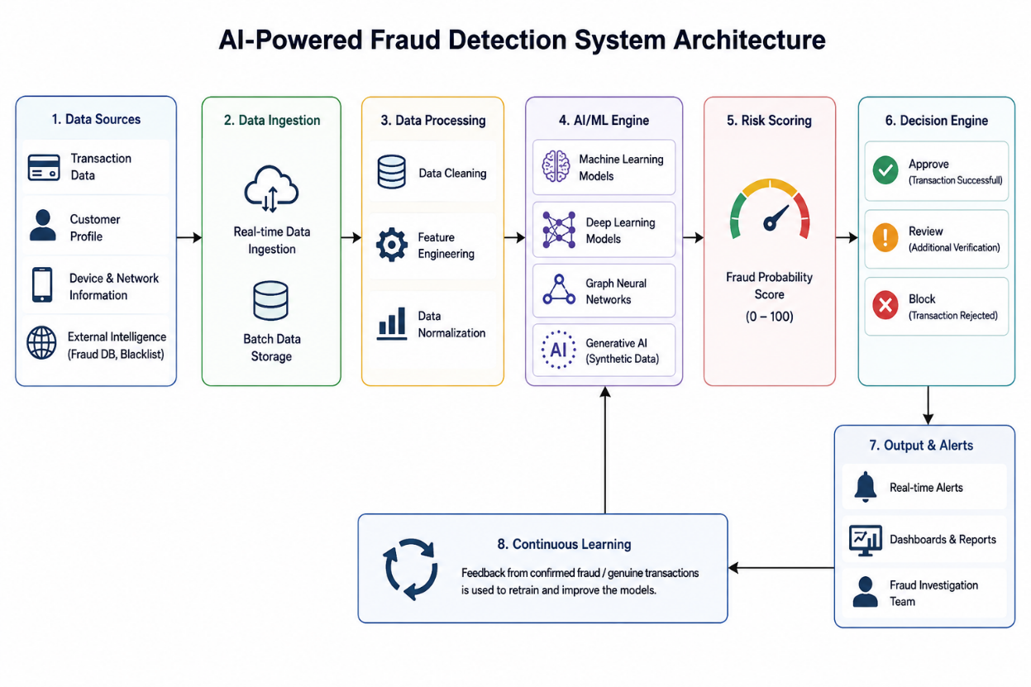
Why These Components Are Used
- Each component of the architecture performs a specific function that contributes to accurate fraud detection.
- The Data Collection Layer gathers transaction information from banking systems, ATMs, online payment gateways, mobile banking applications, customer profiles, device fingerprints, browser information, IP addresses, and previous transaction histories. Without high-quality input data, AI models cannot make reliable predictions.
- The Data Preprocessing Layer removes duplicate records, corrects missing values, normalizes numerical variables, converts categorical information into machine-readable formats, and prepares the data for model training. Clean data significantly improves prediction accuracy.
- Feature Engineering transforms raw transaction records into meaningful indicators such as transaction frequency, average spending amount, time interval between transactions, geographical movement, login patterns, and merchant categories. These engineered features provide the AI model with richer information for learning fraud behavior.
- The Graph Neural Network module analyzes relationships among users, devices, merchants, bank accounts, and IP addresses. Fraud is often organized in interconnected networks rather than isolated transactions. GNNs identify suspicious clusters that traditional machine learning cannot detect effectively.
- Machine Learning models such as Random Forest, XGBoost, and Logistic Regression classify transactions based on historical fraud patterns. Deep Learning models analyze highly complex nonlinear relationships among transaction variables.
- Generative AI creates realistic synthetic fraud samples, helping overcome the problem of highly imbalanced datasets where genuine transactions greatly outnumber fraudulent ones.
- The Risk Scoring Engine combines predictions from multiple AI models into a single fraud probability score. The Decision Engine then determines whether to approve, temporarily hold, or reject the transaction.Finally, the Continuous Learning Module updates AI models as new fraud techniques emerge, allowing the system to remain effective without complete redesign.

AI Technologies Used
- The fraud detection system integrates several AI technologies.
- Machine Learning algorithms including Random Forest, Gradient Boosting, XGBoost, and Logistic Regression classify transactions based on historical behavior.
- Deep Learning models such as Artificial Neural Networks (ANNs) and Long Short-Term Memory (LSTM) networks capture complex sequential transaction patterns and detect subtle behavioral changes over time.
- Graph Neural Networks (GNNs) identify hidden relationships among customers, merchants, devices, and bank accounts, enabling detection of organized fraud rings and money laundering networks.
- Natural Language Processing analyzes customer complaints, emails, SMS messages, and chatbot interactions to detect phishing attempts and suspicious communications.
- Generative AI produces synthetic fraud scenarios that improve training datasets, allowing AI models to recognize new attack techniques before they occur in real-world environments.
- Explainable AI (XAI) provides transparent explanations for fraud decisions, helping investigators understand why a transaction was classified as suspicious.

Working Mechanism
- The fraud detection process begins when a customer initiates a financial transaction. Transaction details, customer information, device characteristics, IP address, GPS location, transaction amount, payment method, merchant information, and account history are immediately collected.
- The preprocessing module cleans the incoming data and extracts meaningful features. These features are simultaneously analyzed by Machine Learning, Deep Learning, and Graph Neural Network models.
- Each model independently estimates the probability of fraud. Their outputs are combined by an ensemble decision model to generate an overall fraud risk score ranging from 0 to 100.
- If the score is low, the transaction is approved instantly. If the score is moderate, additional authentication such as One-Time Password (OTP), biometric verification, or facial recognition may be requested. If the fraud probability is high, the transaction is blocked automatically, and fraud investigators are notified.
- Every confirmed fraud case is added to the training dataset, allowing continuous improvement of future predictions.

Data Sources and Processing
- The AI system relies on multiple categories of financial data to make intelligent decisions.
- Transaction data includes payment amount, transaction time, merchant category, payment channel, account balance, and transaction frequency.
- Customer profile data includes age, occupation, banking history, account type, credit score, and historical financial behavior.
- Behavioral data captures login frequency, typing speed, touchscreen interactions, mouse movement, and purchase preferences.
- Device data contains browser information, operating system, device fingerprint, SIM details, IMEI number, and IP address.
- Network relationship data represents connections among customers, merchants, devices, bank accounts, phone numbers, and payment gateways using graph structures.
- External intelligence includes fraud blacklists, cybersecurity feeds, sanction lists, stolen card databases, and suspicious account registries.
- After preprocessing, these data sources are transformed into numerical feature vectors that AI models use for prediction.

Real-World Implementation
- Many leading financial organizations have implemented AI-powered fraud detection systems.
- JPMorgan Chase uses AI and machine learning to monitor payment fraud, detect suspicious account activities, and improve transaction security.
- Mastercard Decision Intelligence applies AI to evaluate payment behavior in real time and reduce false transaction declines.
- Visa Advanced Authorization uses deep learning to analyze billions of transactions annually and identify fraudulent activities within milliseconds.
- PayPal employs machine learning to detect account takeover attacks, payment fraud, and unusual customer behavior.
- American Express utilizes AI models to monitor global credit card transactions and identify abnormal spending patterns while minimizing inconvenience for legitimate customers.
- Banks in India, including HDFC Bank, ICICI Bank, Axis Bank, and SBI, also use AI-based fraud monitoring systems to secure UPI, internet banking, and digital payment platforms.

Impact and Benefits
- AI-powered fraud detection has transformed financial security by significantly increasing fraud detection accuracy while reducing operational costs.
- Real-time transaction monitoring enables banks to detect fraud within milliseconds rather than after financial losses occur.
- Machine learning models continuously improve detection performance as new transaction data becomes available.
- Graph Neural Networks successfully identify organized criminal networks involved in money laundering and synthetic identity fraud.
- Generative AI improves model robustness by creating realistic fraud simulations for training.
- Customers experience faster transaction approvals with fewer false declines, improving user satisfaction.
- Financial institutions reduce investigation costs, regulatory penalties, and financial losses while increasing customer trust.

Challenges and Limitations
- Data Privacy Issues: AI systems process sensitive customer financial data, so protecting privacy and complying with regulations (GDPR, RBI guidelines, etc.) is essential.
- Data Imbalance: Fraudulent transactions are very few compared to genuine transactions, making it difficult to train accurate AI models.
- High Implementation Cost: Developing and maintaining AI infrastructure requires significant investment in hardware, software, and skilled professionals.
- False Positives: Sometimes genuine transactions are incorrectly flagged as fraudulent, causing inconvenience to customers.
- Model Explainability: Deep learning models often act as "black boxes," making it difficult for banks to explain why a transaction was blocked.
- Evolving Fraud Techniques: Cybercriminals continuously develop new fraud methods, requiring AI models to be updated regularly.
- Cybersecurity Risks: AI systems themselves can become targets of adversarial attacks or data manipulation.
- Integration Challenges: Integrating AI with existing banking systems and legacy infrastructure can be complex and time-consuming.

Future Scope and Emerging Trends
- Generative AI for Fraud Simulation: AI will generate realistic fraud scenarios to improve model training and detect new attack patterns.
- Advanced Graph Neural Networks (GNNs): Future systems will better detect organized fraud rings and money laundering networks.
- Federated Learning: Banks will collaboratively train AI models without sharing customers' sensitive data, improving privacy.
- Explainable AI (XAI): AI models will provide clear explanations for fraud detection decisions, increasing transparency and regulatory compliance.
- Real-Time Adaptive Learning: AI systems will continuously learn from new transaction data and adapt to emerging fraud techniques automatically.
- Integration with Blockchain: Combining AI with blockchain technology will improve transaction transparency, security, and traceability.
- Multi-Modal AI: Future systems will analyze transaction data, voice, text, biometrics, and customer behavior together for more accurate fraud detection.
- Quantum-Resistant Security: Future AI-powered banking systems will incorporate quantum-safe cryptography to protect against next-generation cyber threats.

Conclusion
AI-powered fraud detection systems using Machine Learning, Deep Learning, Graph Neural Networks, and Generative AI represent one of the most advanced applications of Artificial Intelligence in the finance domain. Unlike traditional rule-based systems, AI continuously learns from financial transactions, adapts to new fraud techniques, and makes intelligent decisions within milliseconds. The architecture combines multiple AI components—including data preprocessing, feature engineering, graph analysis, ensemble learning, and continuous model updates—to provide highly accurate fraud detection while minimizing false alarms. Leading organizations such as JPMorgan Chase, Visa, Mastercard, PayPal, and major Indian banks have successfully implemented these systems to secure digital banking and payment services. Although challenges related to privacy, explainability, computational cost, and cybersecurity remain, ongoing research in Explainable AI, Graph Neural Networks, Federated Learning, and Generative AI is expected to make future fraud detection systems even more intelligent, transparent, and reliable. This application demonstrates how AI is transforming financial security by protecting customers, reducing economic losses, and enabling safer digital financial ecosystems.

References (Recent and Reliable)
- Akoglu, L., Tong, H., & Koutra, D. (2021). Graph-Based Anomaly Detection and Description: A Survey. ACM Computing Surveys.
- Goodfellow, I., Bengio, Y., & Courville, A. (2016). Deep Learning. MIT Press.
- IEEE Access (2024). Artificial Intelligence for Financial Fraud Detection: Recent Advances and Future Trends.
- Springer Nature (2024). Machine Learning and Deep Learning Applications in Banking Fraud Detection.
- Mastercard. Decision Intelligence for Fraud Detection.
- Visa. Visa Advanced Authorization AI Platform.
- JPMorgan Chase. Artificial Intelligence and Machine Learning in Financial Services.
- PayPal Engineering. Machine Learning for Real-Time Fraud Detection.
- Deloitte Insights (2025). AI in Financial Services: Fraud Detection and Risk Management.
- McKinsey & Company (2025). The Future of Generative AI in Banking and Financial Security.

Rubrics for Evaluation
S.No | Criteria | Weightage (%) | Excellent (100–90%) | Good (89–75%) | Satisfactory (74–60%) | Improvement (
1. | Identification of Latest AI Application | 10% | Selects a highly relevant, emerging AI application with strong justification. | Selects a recent and relevant AI application. | Selects a suitable application with limited justification. | Application is outdated or irrelevant.
2. | Problem Analysis and Domain Understanding | 15% | Clearly explains the real-world problem, domain context, and need for AI with critical analysis. | Good explanation with adequate analysis. | Basic explanation with limited analysis. | Problem statement is unclear or incomplete.
3. | AI Technologies and Working Mechanism | 20% | Accurately explains AI techniques, algorithms, architecture, and workflow with technical depth. | Good explanation with minor omissions. | Covers only basic AI concepts. | AI technologies are poorly explained or incorrect.
4. | Research Quality and Literature Review | 10% | Uses recent, credible sources with proper citations and excellent synthesis. | Good quality references with appropriate citations. | Limited references with basic discussion. | Few or unreliable references; poor citation.
5. | Real-World Implementation and Case Analysis | 10% | Thoroughly analyzes industrial implementation with appropriate examples. | Good implementat ion analysis. | Basic implementation discussion. | Minimal or no real-world analysis.
6. | Impact, Challenges, and Future Scope | 15% | Critically evaluates benefits, limitations, ethical issues, and future trends. | Good evaluation with minor gaps. | Basic discussion of impact and future scope. | Limited evaluation or missing sections.
7. | Originality and Critical Thinking | 10% | Demonstrates independent research, innovation, and critical evaluation. | Good analytical thinking. | Some originality with limited analysis. | Mostly descriptive or copied content.
8. | Organization, Presentation, and Documentation | 10% | Exceptionally organized, professional presentation, error-free, and properly referenced. | Well organized with minor issues. | Adequately organized with some errors. | Poor organization and documentation.

